**HTML | <tfoot> valign Attribute**

Last Updated : 21 Feb, 2022

The **HTML <tfoot> valign Attribute** is used to *specify the vertical alignment of text content in a table footer cell*. It is not supported by HTML 5.

**Syntax:**

<tfoot valign="top | middle | bottom | baseline">

**Attribute Value:**

* **top:** It sets the content to top-align.
* **middle:** It sets the content to middle-align.
* **bottom:** It sets the content to bottom-align.
* **baseline:** It sets the content to baseline. The baseline is the line where most of the characters sit. It is a default value.

**Example:**

|  |
| --- |
| <!DOCTYPE html>  <html>    <head>      <title>          HTML tfoot valign Attribute      </title>  </head>    <body>      <h1>GeeksforGeeks</h1>        <h2>HTML tfoot valign Attribute</h2>        <table border="1" width="500">          <tr>              <th>NAME</th>              <th>AGE</th>              <th>SUBJECT</th>          </tr>            <tr>              <td>BITTU</td>              <td>22</td>              <td>CSE</td>          </tr>            <tfoot valign="top">              <tr style="height:70px">                  <td>Name@123</td>                  <td>Age@123</td>                  <td>Branch@123</td>              </tr>          </tfoot>      </table>  </body>    </html> |

**Output:**  
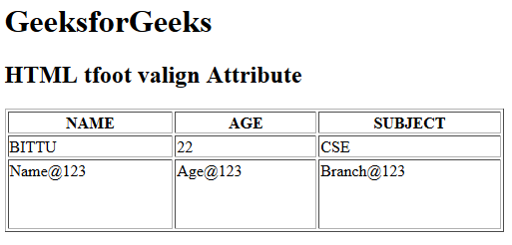

**Supported Browsers:** The browser supported by **HTML <tfoot> valign attribute** are listed below:

* Google Chrome
* Internet Explorer
* Firefox
* Safari
* Opera

Dive deep into the world of JavaScript with our [JavaScript Full Course Online](https://www.geeksforgeeks.org/courses/javascript?utm_campaign=three_90_345_abt&utm_medium=gfgcontent_abt&utm_source=geeksforgeeks), offering everything from the basics to advanced techniques. Learn how to build interactive websites, optimize your code, and earn a certification to showcase your skills.  
  
Take the **Three 90 Challenge**! Complete **90% of the course** in **90 days**, and **earn a 90% refund**. Push your limits and stay motivated as you work towards mastering JavaScript. Join now and get started on your **JavaScript learning journey!**

Comment

More info

[Advertise with us](https://www.geeksforgeeks.org/about/contact-us/?listicles)

[**Next Article**](https://www.geeksforgeeks.org/html-td-valign-attribute/?ref=next_article)

[HTML <td> valign Attribute](https://www.geeksforgeeks.org/html-td-valign-attribute/?ref=next_article)

**Similar Reads**

**[HTML | <tfoot> valign Attribute](https://www.geeksforgeeks.org/html-tfoot-valign-attribute/?ref=ml_lbp)**